Social Services Board
Charles I. Mitchell, Chair
Jacqueline Beatty-Smith, Vice Chair
Wendy Sotolongo
Dionne Moore
Commissioner Stephen Valentine

Maggie Clapp
DSS Director

January 16, 2025

MEMORANDUM

TO: Maggie Cveticanin, Director

FROM: Latoya W. Chambers, Interim Assistant Director
Family Economic Independence Division

RE: FEI Board Written Report

December Highlights:
- Work First Cash recertifications passed timeliness expectations with 100% and applications timeliness was 99.32% which exceeds the state’s expectation of 95%. The program has been passing timeliness in both categories since February 2024.
- Food & Nutrition Services passed recertification timeliness with 99.19% which is above the 95% expectation.
- Food and Nutrition Services applications passed Expedited timeliness with 96% and we are continuing to improve timeliness for Regular processing as well.
- We had staff from FEI that assisted with making referrals and gift distribution for Share your Holiday for 181 families.
- We onboarded two new social workers which began NC FAST/Policy training on January 6th.
- FEI division staff participated in numerous holiday events including the Durham DSS Cookie Bake Off on December 11th. Staff were able to get a photo op with the Grinch himself.

DSS Holiday Bake Off – FEI Division Participants

Kalika Moore & Roshanna Harrell

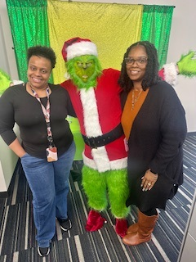

Child Care & Family Services Holiday Events

