

**Durham Convention Center Authority Meeting**

Thursday, August 29, 2019

Durham Convention Center

301 West Morgan Street

**DCC Authority Members** Present: *Bill Kalkhof, Lew Myers, Alice Sharpe, Craig Spitzer, and Darah Whyte.* **Spectra Venue Management (SVM)** Present: *Rebecca Bolton and Andrea Gliatta*

**City and County Representatives** Present: *Drew Cummings, Sharon DeShazo, April French, Carlos McCall, Trish Creta, Kirby Lee, Jina Propst, and Karmisha Wallace*

**RND Architects presentation – Exterior Signage (Capital Project)**

1. A quorum was established for meeting minute’s approval. Lew Meyers made a motion to approve June 27, 2019 meeting minutes; seconded by Bill Kalkhof, motion carried; minutes approved.
2. **REBRANDING:**

The rebranding project will mostly fund a new DCC logo design. Rebecca has logo renderings and a design has been chosen. She is currently in discussion with RND to match the logo with the exterior signage project and is planning a “teasing” preview on Instagram. The design is not ready for DCCA to review. Stay tuned.

1. **OCTOBER MEETING DISCUSSION – Spectra’s Incentive:**

Compliance with the DCC Audit outcome is needed for approving Spectra’s incentive for the fiscal year:

* Completion
* Self-Evaluation
* Survey to stakeholders

Currently, the Audit Report is not 100% complete. Request for approval of the Audit (twelve procedures specified in the audit report) planned for the October 31, 2019 meeting.

1. **DURHAM City/County Administration Update:**

**Capital Projects: FY2019: Budget:**

**Fireproofing**

PFC $66,000  
Loading Dock - Shared $21,000

Additional funds needed for loading dock ($8,000) estimate

* 95% of fireproofing in the original contract is complete, with only 5% of the work remaining. Total completion is anticipated by the end of the calendar year (November/December 2019). The contract total is $85,441.00.
* Additional fireproofing beyond the original budget is required. General Services received a proposal for 1,000 square feet of additional fireproofing ($8,000) and 200 square feet of ceiling tile replacement ($600) for a total additional fee of $8,600. Cost is an estimate based on a unit price and could be more or less pending on what issues are found.
* General Services is requesting that the DCCA approve the allocation of additional funding at the August 29, 2019 DCCA meeting.

**Kitchen Equipment Improvements** (equipment and installation) $53,000

**Phase I**

* + The contractor and equipment installer provided quotes for a new dish-pit upgrade, and the team is coordinating jurisdictional approvals with City Inspections and County Health Department. The project will need the remaining budget for phase II.
  + The work is being scheduled for the latter part of December 2019 and the first week of January 2020.
  + The work is estimated to complete at $37,548, potentially having an excess of $15,000. General Services anticipates being over budget by a similar amount.
  + General Services is requesting that the DCCA approve reallocation of funding for Phase II once all quotes are received. These are actions that need to occur.

**Capital Project FY2020 Budget:**

**Exterior Signage** (Carry over to FY2020) $55,000

Additional funding needed ($31,000) estimate

* + RND Architects are updating the 2013 design and construction documents for the Plaza side entrance. Scope includes coordinating signage with rebranding, extending canopy to provide more emphasis on entry and protection from elements, incorporate lighting not included in previous design to enhance the design for improved street presence. Scope to include construction administration.
  + RND Architects are present to discuss modification of signage concept during the August 29, 2019 DCCA meeting.
    - New canopy
    - Review of reorganization for trees
    - Position of signage
    - Backlighting for letters

**Kitchen Project Phase II**

* + - Kitchen Equipment $50,000
    - Kitchen Combi Oven $24,000
    - Walk-in Freezer $28,000
    - Hot Boxes $4,000
    - Small-wares $30,000
      * Contractor and equipment installer are preparing quotes for Phase II scope, and meetings are ongoing.
      * Work and equipment installation is being coordinated with Phase I for December 2019/January 2020.
      * Hot boxes and small-wares purchase in November/December 2019.

**Interiors Projects**

* + - Interior Designer $30,000
* Bathroom Renovation $50,000

Timeliness of the bathroom project is on track

* Prefunction Furniture $29,274
  + General Services recommends approval of RND for interior design project, due to consistency and efficiency from current involvement with the Signage project, as well as knowledge of facility from other past interior projects. Contract execution is anticipated in September 2019.

**Airwall Damage**  $44,000

* In process of requesting updated quotes

**Wireless Upgrade**  $40,000

* Meeting held with vendor on August 27, 2019. Vendor researching option of using NC State Contract for Meraki access point purchase. Next meeting is in mid-September.

**Rooftop Air Handler** $40,000

* + General Services and the HVAC vendor collaborated on the investigated equipment and determined the rooftop air handler can be deferred for three to five years.
  + General Services and the DCC recommend the DCCA approve reallocation of Rooftop Air Handler fund for Exterior Signage and Fireproofing Projects.

**Security Cameras** $40,000

**Small Wares** $30,000

**Walk-in Freezer** $28,000

**Kitchen Ovens** $24,000

**Phase II Kitchen** $50,000

* All work noted above, is in progress for initiation and contracting by mid-July and no later than the first quarter of FY2020.
* Trish Creta suggested reaching out to vendors on State Contracting to get pricing on replacing needed computer equipment; also, to get RND Architects under contract for the Interior Designer portion of the project, then review the dates for scheduling of the bathroom renovation project. There is concern about project scheduling and having the ability to shut down restrooms to begin the work during the busy periods. Once all information is compiled, a correspondence circulates to the DCCA.

**Security System**

* + The meeting held with DCC and General Services on August 27, 2019. A walk-through with the vender is scheduled for September 5. The scope of work is anticipated to occur in October/November 2019.

**ADDITIONAL PROJECTS BUDGET**

**(Funds Needed)**

**Database Software Upgrade** $7,000

**Computer Replacement** To be determined

* + Microsoft Seven is coming to the end of its useful life support in 2020; this opens up the system to security threats.
  + The technology vendor recommends replacing computers nearing their hard-drive capacity with new systems upgrades to Windows 10.
  + The vendor is providing a specification to the City so that pricing is quoted through the vendor on North Carolina State Contract.
  + The cost will be shared with the DCCA at the October 31, 2019 meeting.

**Mural and Lighting for Mural**

* Cornelio Campos mobilized on August 27, 2019; the mural is underway, and completion is anticipated by September 3, 2019.
* Cecelia Lueza will mobilize the week of September 3, 2019, and completion is anticipated during the week of September 9, 2019.
* DCC is in the process of receiving quotes for LED lighting that is appropriate for this application.

Murals will be introduced to the community during Centerfest – September 18, 2019.

1. **SPECTRA VENUE MANAGEMENT (SVM) UPDATE:**

**Events for the month of JULY 2019**

SVM held 23 events with 3,065 guests.

**Notable events: DCC Revenue Guests**

* + - * University Wisconsin (6 day event) $86,512 2008
      * Funeral Directors (4 day event) $26,441 375
      * State Voices (3 day event) $35,853 300
      * QuirkCon (3 day consumer show) $27,199 1,000
      * Duke Heart Center (1 day convention) $19,806 270
      * New Hope (3 day convention) $15,391 1,500
      * FHI 360 $19,418 203
      * Center for Budget Policy (4 day meeting) $43,301 245

**ADDITIONAL NOTES:**

* Citywide Events – Armory, Carolina Theater, DPAC – secured two citywide contracts (ISPE March 2020, NCSHRM August 2021)
* Aisha Cotton – Google Analytics Certified
* Event Manager Position
* Facilities and Destinations Magazine – Prime Site Award

**FINANCIAL OVERVIEW FOR JULY 2019**

**Actual Budget Variance**

Gross Revenues $103,189 $88,356 $14,833

Less Event Expenses ($46,710) ($33,274) ($13,436)

Less Indirect Expense ($138,725) ($152,978) $14,253 ___

Net Income (Loss)  **(**$82,246) ($97,896) $15,650

**2020 Annual Budget Revenue Projection Status**

|  |  |  |
| --- | --- | --- |
| Total Projection | Budgeted Total Gross Income | % of the Gross Year-end Budget |
| $2,162,824 | $2,708,132 | 80% |

**Sales Pace for FY2020 as of August 26, 2019**

|  |  |
| --- | --- |
| Definite/Actual Total | $         1,563,844 |
| Firm Total | $         160,318 |
| Proposal Total | $         438,662 |
| Total Projection | $         2,162,824 |

**Occupancy in JULY 2019: 43%**

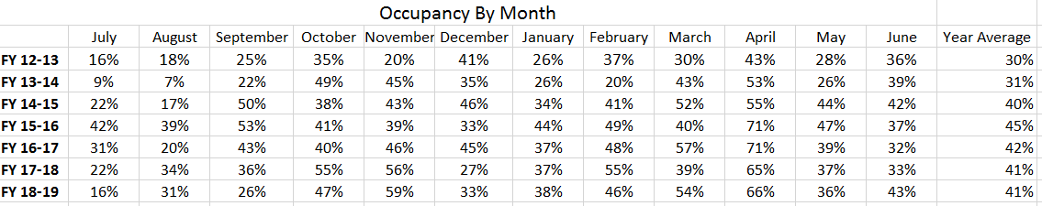

**Rolling Forecast**

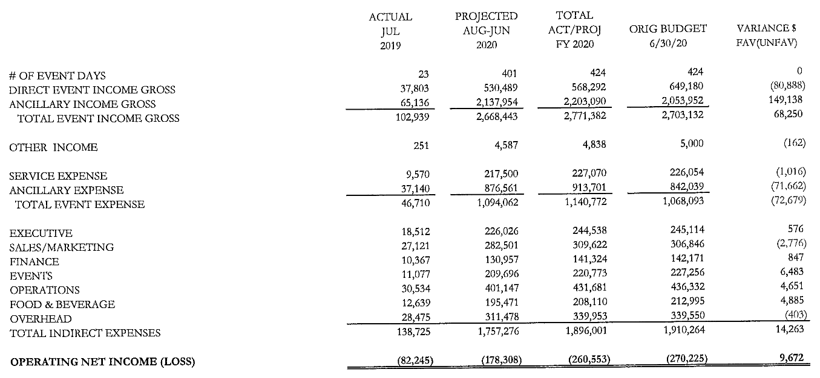

**CUSTOMER SURVEY SCORES:** 4.72 out of 5

**WEBSITE ACTIVITY:** June 16th – July 16th

**2018 2019**

* + Sessions (Visitors): 900 1,198
    - * New Sessions: 85.8% 87.8%
      * Page Views 2,583 2,798
  + Page/Session: 2.87 2.34
  + Average Session duration: 1.54 minutes 1.27 minutes
  + Organic Search 523 617
  + Direct Search 227 333
  + Referral Search 28 69

Rebecca Bolton and Jina Propst continue to work in partnership on improvements for the Plaza for a more inviting space.

1. **DCCA**

Does the Interlocal agreement speak to online correspondence (meetings – voting on-line). General Services staff to review and report back.

On behalf of the DCCA, Craig Spitzer made a motion to proceed with the computer replacement project, which may require reallocating capital funds. Project based on necessity (per hard-drive obsolescence) is needed by end of the year. Additional correspondence will follow via email once bids are received. The Authority may be asked to vote at the October meeting or provide affirmation via email prior to the meeting. Bill Kalkhof seconded. The sooner the purchase can be made optimum support for the DCC operation.

On behalf of the DCCA, Craig Spitzer made a motion to reallocate approved funding (approximately $40,000) to the DCC for the exterior signage line item instead of replacing the rooftop air handler (HVAC) equipment for FY2020. The HVAC equipment project has been deferred three to five years out. Bill Kalkhof seconded; motion carried and approved by all.

1. **SUBCOMMITTEES**

* **FINANCE COMMITTEE**: *Lew Myers, Richard Ford, and Craig Spitzer*

City and County staff, the DCCA Finance Committee, and members of Spectra Venue Management discussed July 2019 financial results. Operating revenues for the month exceed budget by $14,833. Expenses reveal a net subsidy of $82,246. To-date there is $90,807 in outstanding receivables. There are personnel savings with two vacancies: event manager and executive chef totaling $11,365 for the month. The Owners anticipate an audit report in October at the next DCCA meeting. There are minimal changes in this FY2019 audit report.

* **MARKETING & SALES COMMITTEE***: Bill Kalkhof, Darah Whyte, Alice Sharpe, and Craig Spitzer*

Spectra Venue and members of the Marketing and Sales committee continue to collaborate on Spectra Venue’s DCC marketing plan.