

**Durham Convention Center Authority Meeting**

Thursday, September 28, 2017

Durham Convention Center

301 West Morgan Street

11:30 AM (Lunch)

**DCC Authority Members** Present: *Richard Ford*, *Jason Friday Bill Kalkhof, Lew Myers, Alice Sharpe, Craig Spitzer, and Darah Whyte.*

*Cecily Kalkhof, Director of Relocation and Business Development*

**Spectra Venue Management (SVM)** Present: *Andrea Gliatta and Rebecca Bolton*

**City and County Representatives** Present: *Steven Hicks,* *David Boyd*, *Sharon DeShazo, Jina Propst, Todd Tingler, Drew Cummings and April Jones.*

1. The meeting was called to order at 11:45 PM by Bill Kalkhof, DCCA chairperson. Bill introduced his wife, Cecily Kalkhof.
2. A quorum was established for meeting minute’s approval. Lew Meyers made a motion to approve August 31, 2017, meeting minutes; seconded by Alice Sharpe, motion carried; minutes approved.
3. **WALKTHROUGH OF LOADING DOCK:**

* Members of the DCCA had an interesting walk-through of the loading dock to review changes made over the last six months immediately following the meeting adjournment.

1. **FY2016/17 AUDIT REVIEW**

David Boyd, City of Durham Finance Director, provided a comparative analysis on how the City of Durham tracked financial data for Durham Convention Center reconciliation and presented the FY2016/17 Financial Statement of revenues, change in fund balance, and the independent accountant’s report on applying agreed-upon procedures performed by Cherry Bekaert. George Quick, Durham County Finance Director, and David Boyd worked with the auditor to define the twelve procedures specified in the report. There were no findings. Spectra’s operations were well received based on DCC financials provided. Both City and County Finance Directors provided correspondence to note agreement of the report performed. On behalf of the DCCA, Lew Myers made a motion to move and accept the DCC FY2016/17 audit report; seconded by Craig Spitzer, motion carried and approved by all.

1. **Durham City/County Administration Update:**

**UTILITIES ANALYSIS/SPLIT AND RETRO-COMMISSIONING:**

* + **Utilities analysis**: MBP continues to monitor the chilled water BTU demand and overall electric split on a monthly basis (since November 2016). Results indicate an overall allocation of 60/40 instead of 50/50 based on usage. Staff will collect data for one year, prior to implementation and any retroactive payments; follow-up with a meeting with Shaner to discuss results and next steps in the process.
  + **Retro-commissioning project:** No update to report. DCC staff is issuing a purchase order to the controls vendor, Champion Systems, for a software upgrade, new computer, and training.
* **CAPITAL REPLACEMENTS PLAN:** The Capital Replacement Plan tool was reviewed in early June by GSD and DCC Spectra staff to begin planning for FY 18 project implementation. A Review of capital planning tool is scheduled for September 29, to finalize needs for the next five years and project needs for FY 19/20.
* **DCC PROJECTS (including joint Shaner projects):**

Shared public space:

* + The Shared Space Renovation work is complete. The staff will continue to monitor throughout the one year warranty period.
  + **Loading Dock and PFC Fireproofing:** Due to the large workload in the area, GSD Project Management Division is experiencing difficulty soliciting a fireproofing contractor for the fireproofing scope of work. Staff will continue to seek out contractors for pricing, starting with the Loading Dock and PFC investigation.

**Approved projects: FY17/18:**

* + Fireproofing (carry-over FY16)

PFC $60,000  
Loading Dock $21,000

* + LED Lighting Replacement $137,500

PFC, Meeting Rooms, Back of House

and Loading Dock (Loading Dock completed, in process of finalizing procurement for other areas)

* Boardroom and Alcove Carpet $10,000

(Carpet selected, anticipated completion November 2017)

* + MBP Implementation/Facility Dude PM $10,000

Underway

* + Kitchen Equipment Improvements $53,000

(Conceptual planning underway)

* + Carpet Extractor $10,000
  + Trash Cans and Recycling Receptacles $10,000
  + A/V Upgrade $10,000

(Scott Brown Media contract implemented, A/V upgraded no longer an option – reallocate funds)

* + Bathroom Renovation $50,000

(Initiate in September 2017)

* Fountain-shut down early August. Repairs next steps and corrective action/estimating under review
* **END OF YEAR PERFORMANCE – Review and approve incentive recommendation:** In addition to the financial report noted in item IV above, the Board reviewed the annual DCC self - evaluation and the review conducted by the DCVB related to the performance of Spectra. Kalkhof noted that most scores were at or higher than desired 4.2 marks except DCC Parking which was below the 4.2 due to circumstances beyond the control of Spectra management. He also commended Rebecca Bolton, Spectra GM responded to all comments scored 3 and below. For purposes of determining the Spectra incentive, 70% of the evaluation is financial, and 30% is qualitative. City and County ownership support incentive payment in the amount of **$106,850.92.** The language in the management agreement defines how the incentive fee is calculated (Section 3.2 Incentive Fee). On behalf of the DCCA, Alice Sharpe made a motion to support the recommendation of the Owners to provide the FY2016/17 incentive fee due to Spectra Venue Management for their financial and management performance; seconded by Bill Kalkhof, motion carried and approved by all.

1. **Spectra Venue Management (SVM) Update:**

**EVENTS FOR THE MONTH OF July 2017**

SVM held 21 events with 3,045 guests.

**Notable events: DCC Revenue Guests**

* + - * New Hope - NHACNA $15,000 600
      * One Hit Boxing $11,000 634
      * Jay Michael Fashion Show $11,000 1200

**New Bookings:**

* Global Knowledge November 2017 and 2018
* Duke University New Student Programs
* Two Indian Weddings September 2017
* Two Conventions 2019
  + - National Institute for Psychoanalytic Education and Research
    - Carolina’s Parking Association

**Public Relations/Advertising/Networking**

* Marketing Calendar
* Fall Promotion
* AENC Annual Meeting
* MPI Bi-monthly Board Meeting
* IAVM Venue-Connect
* Downtown Partnership
* Charlotte sales calls with Marriott
* Duke Meeting Planners Breakfast
* National Joke Day Blitz

**Operations**

* Water Fountain
* LED Replacement
* Scott Brown Media Group – partnership begins September 1, 2017. Currently the DCC only profits 47% on A/V reconciliation. The recommendation is to have a dedicated A/V employee on site to increase the profit percentage. There is language to dissolve the A/V contract. It will assist in keeping in line with up-to-date equipment and decrease labor cost on the DCC end.
* The Rotary will be moving on to the DBAP – Durham Baseball Athletic Park by December 2017. The DCC will not be losing income by moving this event to the DBAP.

**OCCUPANCY**: For the month of July 2017 is 22%.

**FINANCIAL OVERVIEW FOR THE MONTH OF JULY 2017**

**Actual Budget Variance**

Gross Revenues $74,106 $87,701 ($13,595)

Less Event Expenses ($36,632) ($35,295) $1,337

Less Indirect Expense ($128,279) ($142,235) $13,956

Net Income (Loss)  **(**$90,805) ($89,828) ($977)

*Net Income (Loss) is $977; August 2017 is currently at $70,000 above budget (variance for total operating rev/operating exp). The DCC is forecasting deeper on return business and has 30% new business.

**Sales Pace for FY2017/18 as of 08/25/2017**

|  |  |
| --- | --- |
|  |  |
| * + Definite Total | * + $1,379,517 |
| * + Firm Total | * + $76,107 |
| * + Proposal Total | * + $265,462 |
| * + Total Projection | * + $1,721,086 |

**\***Definite revenue is ahead of same time last year by 30%.

**Annual Budget Revenue Status – FY 2017/18:**

|  |  |  |
| --- | --- | --- |
| Total Projection | Budgeted Total Gross Income | % of Gross YTD |
| $1,721,086 | $2,485,708 | 69% |

**FORECAST**

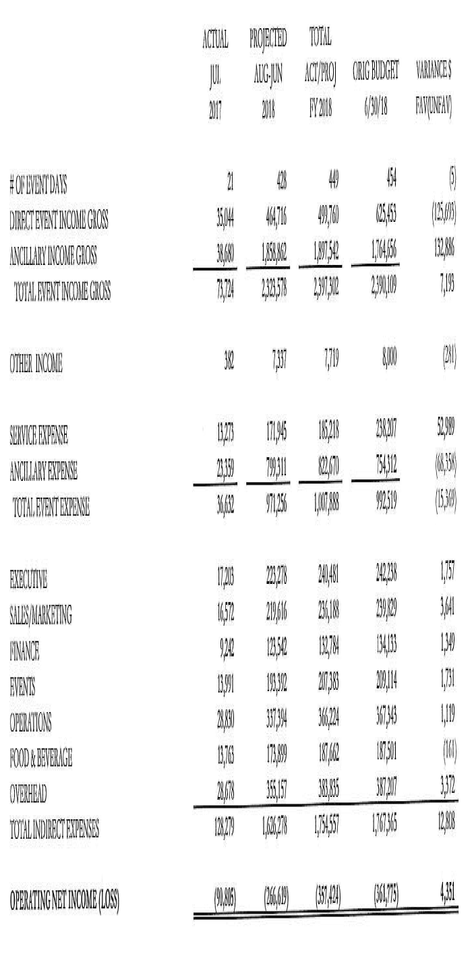

**CUSTOMER SURVEY SCORES:** 4.47 out of 5.

**WEBSITE ACTIVITY:**

**2017 2016**

* + Sessions (Visitors): 1,013 1,829
    - * New Sessions: 86.87% 81.57%
      * Page Views 2,783 4,533
  + Page/Session: 2.75 2.48
  + Average Session duration: 1.10 minutes 1:30 minutes
  + Organic Search 662 821
  + Direct Search 225 504
  + Referral Search 118 495
  + Social Search 7 9

Events have declined, but attendance has increased over the years to enhance the financial bottom line.

The sales team is focusing on doing business with the Durham Visitors and Convention Bureau (DCVB).

1. **DURHAM CONVENTION CENTER AUTHORITY:**

**Election of DCCA Chair and Vice Chair Positions:**

* 1. Alice Sharpe made a motion to nominate Bill Kalkhof to continue as Authority chair for an additional year through August 2018; Craig Spitzer seconded, motion carried and approved by all.
  2. Bill Kalkhof made a motion to nominate Richard Ford as vice chair for an additional full year term through August 2018; Craig Spitzer seconded, motion carried and approved by all.

1. **CONSULTANT REPORT Update:**

The DCCA continued its ongoing discussion to review the feasibility of undergoing a consultant’s report regarding its future and why this should occur. The next step in this process is collaborating with DCVB for advice on where markets are going and how the DCC fits. (*Subsequent to this meeting, Kalkhof scheduled a meeting with Shelly Green of the DCVB, Craig Spitzer and Rebecca Bolton. Kalkhof will provide a report and recommendations resulting from this meeting at the October DCCA meeting*). A lengthy discussion focused on how the Armory and the Carolina Theatre could be better positioned to become key partners with the Convention Center related to the recruitment of larger conventions to Durham which require larger space that can only be provided via a partnership of the three facilities cluster. Rebecca Bolton informed the DCCA of her recommendation to open discussions with the Theatre and Armory to identify specific goals of the three facilities regarding their missions and clientele, while at the same time determining any opportunities to work together related to how we might match the goals and missions of the three facilities and create a process for the three facilities to work as a team to recruit larger conventions to Durham. Bolton noted her successful partnership with the downtown hotel general managers to work together to develop a single RFP response document to provide to potential clients.

1. **SUBCOMMITTEES**

* **FINANCE COMMITTEE**: *Lew Myers, Richard Ford, and Jason Friday*

City and County staff, the DCCA Finance Committee and members of SVM reviewed and discussed the DCC July 2017 financials. The net subsidy for the month is more than budgeted. Revenues and expenses are under budget for July. July and December are typically the worse revenue-generating months for the DCC. The number of attendance for July is steady with a 5% favorable variance. There are over $73,000 of receivables not yet collected up to 120 days old.

* **MARKETING & SALES COMMITTEE***: Bill Kalkhof, Darah Whyte, Alice Sharpe and Craig Spitzer*

No update to report.