

**Durham Convention Center Authority Meeting**

Thursday, June 29, 2017

Durham Convention Center

301 West Morgan Street

11:30 AM (Lunch)

**DCC Authority Members** Present: *Richard Ford*, *Jason Friday Bill Kalkhof, Lew Myers, Alice Sharpe, Craig Spitzer, and Darah Whyte.*

**Spectra Venue Management (SVM)** Present: *Andrea Gliatta and Rebecca Bolton*

**City and County Representatives** Present: *Steven Hicks,* *David Boyd*, *Sharon DeShazo, Jina Propst, Todd Tingler, Drew Cummings, Al Walker, David Ades and Karmisha Wallace.*

1. The meeting was called to order at 11:45 PM by Bill Kalkhof, DCCA chairperson.
2. A quorum was established for meeting minutes approval. Lew Meyers made a motion to approve April 27, 2017, meeting minutes; seconded by Darah Whyte, motion carried; minutes approved.
3. **DURHAM ROTARY:**

Business continues to improve at the DCC, and as a result, some Rotary meetings have required relocation. In addition, the members of Rotary have complained about the availability of parking. While the weekly meetings add value and prestige to the DCC, revenue is flat. The Rotary is considering a permanent move to the PNC Club at the DBAP. Rebecca Bolton will meet with the Rotary chair to discuss long/short term logistics. Lew Meyers inquired about the tradeoff of continuing to host Rotary meetings at the DCC versus a reduced profit. Currently, the discussion is ongoing.

1. **CONSULTANT REPORT FOLLOWUP:**

After making a recommendation for the City of Durham to consider moving forward with creating a report similar to the Hunden Report, Bill Kalkhof developed a list of questions and issues that a consultant study would be able to address. Bill communicated his draft with the Owners and the other Authority members for review. The Hunden Report is currently obsolete at eight years old; thus encourages the Authority to be proactive regarding the future of the facility. The draft was discussed at the June 29th Authority meeting, and Authority members supported Bill’s outline of questions and issues. Two comments addressed from the draft queried whether City or County staff held the capacity to produce a similar study in-house and if long term capital plans were included in the City’s ten-year plan for expansion. The good news is the DCC is close to being self-sustaining, and according to staff, this would increase the probability of future development. Jina Propst, GSD Assistant Director, advocated for an updated DCC study and shared several critical observations. Next step in this process is to meet with the DCVB. Craig Spitzer, an Authority member, is also a member of the DCVB Board and Bill requested that Craig schedule a meeting with the leadership of DCVB to discuss their opinions regarding a consultant’s report detailing the DCC’s future. Bill asked that Craig Spitzer, Jina Propst, Rebecca Bolton and he represent the DCC at the meeting.

1. **Durham City/County Administration Update:**

**UTILITIES ANALYSIS/SPLIT AND RETRO-COMMISSIONING:**

* + **Utilities analysis**: An upgrade to the City’s Web Supervisor at City Hall housing the Periscope system has successfully implemented. Since the upgrade, City staff is providing MBP with the chilled water BTU demand from Periscope. City Technology Solutions department is working with MBP to provide access to the upgraded system. MBP continues to monitor the chilled water BTU demand and overall electric split on a monthly basis (since November 2016). Results indicate an overall allocation of 60/40 instead of 50/50 based on usage. Staff will collect data for one year, prior to implementation and any retroactive payments.
  + **Retro-commissioning project:** The cooling tower isolation work was complete on June 4. The cooling tower isolation will allow for cleaning and other service of each of the two cooling towers independently without having to shut down the system. The Owners anticipate increased operating efficiency with the modified cooling tower controls sequence. DCC staff is issuing a purchase order to the controls vendor, Champion Systems, for a software upgrade, new computer, and training.
* **CAPITAL REPLACEMENTS PLAN:** The Capital Replacement Plan tool was reviewed in early June by GSD and DCC Spectra staff to begin planning for FY 18 project implementation. Review and planning are ongoing.
* **DCC PROJECTS (including joint Shaner projects):**
  + Shared public space:

The Shared Space Renovation work is complete. The Contractor is now working on Punch List items:

* Painting the Handrail system at the Morgan and Chapel Hill Streets entrances
* Installing the Pedimat walk-off mats in the Morgan and Chapel Hill Streets vestibules
* Completing the new entrance door installation at the Foster Street Main Entrance

**Completion of all Work: July 2017**

* + **Loading Dock and PFC Fireproofing:** GSD is soliciting proposals for the fireproofing scope of work, with a goal of performing the work in August.
* **Projects approved FY 18:**
  + Fireproofing (carry-over FY16)

PFC $60,000  
Loading Dock $21,000

* + LED Lighting Replacement $137,500
* PFC, Meeting Rooms, Back of House

and Loading Dock

* Boardroom and Alcove Carpet $10,000
  + MBP Implementation/Facility Dude PM $10,000
  + Kitchen Equipment Improvements $53,000
  + Carpet Extractor $10,000
  + Trash Cans and Recycling Receptacles $10,000
  + A/V Upgrade $10,000
  + Bathroom Renovation $50,000

1. **End of year audit- performance -** End of year financials will be available in July, Spectra self-appraisal due in July for review, and evaluation. Incentive recommendation and end of year results will be discussed at the August 31 meeting.
2. **Spectra Venue Management (SVM) Update:**

**EVENTS FOR THE MONTH OF May 2017**

SVM held 28 events with 39 event days’ booked and 6,488 guests.

**Notable events: DCC Revenue Guests**

* + - * UNC/NC State Joint Engineering $17,954 350
      * NC Technology Association $67,503 300
      * Hussian Wedding $20,105 350
      * Duke PHD Hooding Grad $74,124 1500
      * Moogfest $30,002 4000
      * NCCU $18,196 400
      * Client Feedback Tool/Client Savvy $32,088 60
      * Faith Assembly Christian $24,975 300
      * Vedaiyan Wedding $72,300 500

**OCCUPANCY**: For the month of May 2017 is 39%.

**CURRENT FINANCES FOR THE MONTH OF MAY**

**Actual Budget Variance**

Gross Revenues $260,681 $276,954 ($16,273)

Less Event Expenses ($93,608) ($117,232) $23,624

Less Indirect Expense ($142,220) ($142,262) $42

Net Income (Loss) $24,852 $17,459 $7,393

**Year to Date**

**Actual Budget Variance**

Gross Revenues $2,439,227 $2,104,436 $334,791

Less Event Expenses $993,044 ($867,726) ($125,318)

Less Indirect Expense ($1,451,519) ($1,582,743) $131,183

Net Income (Loss) ($5,335) ($346,033) $340,698

|  |  |
| --- | --- |
|  |  |
| * + Definite Total | * + $941,021 |
| * + Firm Total | * + $151,785 |
| * + Proposal Total | * + $322,171 |
| * + Total Projection | * + $1,414,981 |

**\***beginning FY18 20% ahead of FY17

**Sales Pace as of June 29, 2017**

|  |  |
| --- | --- |
| Definite/Actual Total | $2,517,961 |

**Annual Budget Revenue Status – FY 2016/17:**

|  |  |  |
| --- | --- | --- |
| Total Projection | Budgeted Total Gross Income | % of Gross YTD |
| $2,517,961 | $2,260,530 | 111% |

**FY 2017/18:**

|  |  |  |
| --- | --- | --- |
| Total Projection | Budgeted Total Gross Income | % of Gross YTD |
| $1,414,981 | $2,398,112 | 59% |

**FORECAST**

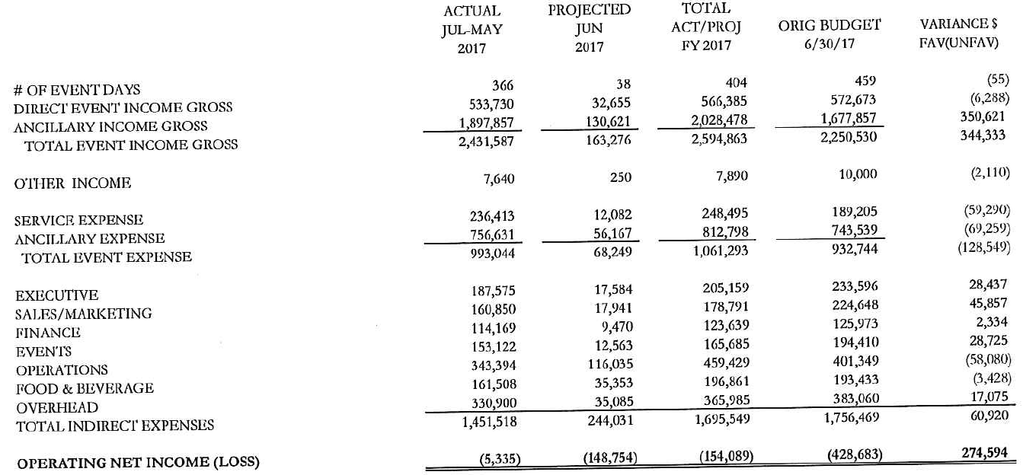

**CUSTOMER SURVEY SCORES:** 4.55 out of 5.

**PROJECTS IN 4TH QUARTER:**

* HVAC Control Upgrade
* Handless sinks in restrooms
* Facility Dude software
* Computers
* Off-site storage
* Small wares – china, glassware, flatware
* Uniforms
* Water fountains
* Back of house – reorganization of interior storage, paint, shelving, baffles, plumbing, electrical
* Exterior – roof repair, concrete repair

**PROJECTS IN 1ST QUARTER:**

* Kitchen
* Facility Dude Implementation
* POS System
* Scott Brown Media Group
* Trash receptacles
* LED Replacement
* Fireproofing
* Loading Dock Plumbing Repair
* Equipment disposal

**WEBSITE ACTIVITY:**

**2017 2016**

* + Sessions (Visitors): 1,606 1,958
    - * New Sessions: 81.18% 83.30%
      * Page Views 3,994 4,351
  + Page/Session: 2.49 2.22
  + Average Session duration: 1.08 minutes 1:17 minutes
  + Organic Search 1,031 1,005
  + Direct Search 440 501
  + Referral Search 126 434
  + Social Search 8 11

**Loading dock doors:** Currently, there is no progress to report regarding a public art project for the loading dock doors. Other DCC projects have taken precedence at this time. We will most likely wait until the loading dock issue regarding a mechanism that opens and closes the door is repaired before re-visiting a public art discussion. The issue implicates cost of repairing the mechanism which parallels similar cost to replace the doors. Alice Sharpe suggested attending a Public Art meeting to bring awareness to the situation, and Bill Kalkhof recommended a follow-up.

1. **DURHAM CONVENTION CENTER AUTHORITY:**

* Ongoing discussion of Bill Kalkhof’s recommendations to the DCCA for the DCC to review the feasibility of undergoing a consultant’s report regarding its future per Bill’s list of bullet points to include comments from the committee and Owners on why this should occur.

1. **SUBCOMMITTEES**

* **FINANCE COMMITTEE**: *Lew Myers, Richard Ford, and Jason Friday*

City and County staff, the DCCA Finance Committee and members of SVM reviewed and discussed the DCC May 2017 financials. The income forecast for the year reveals that the DCC continues to meet budget requirements. The net subsidy for May is $24,852 with a positive budget variance of $7,393. The number of attendance for May exceeded budget by 5,514. The operating budget will not break even this fiscal year due to a significant amount of equipment purchases extracted from the operating budget.

* **MARKETING & SALES COMMITTEE***: Bill Kalkhof, Darah Whyte, Craig Spitzer and No Update to report*.