ODS takes security services seriously and that includes our sworn law enforcement officers who staff our Company Police Services. ODS recognizes that local Police Departments are often limited in staffing and do not always have the ability to respond as rapidly to critical situations that may arise at client sites. Often, local municipalities just don’t have the resources available to maintain an ongoing presence in these facilities. ODS Company Police bridge this gap in security services by providing sworn police officers dedicated to your facilities.

[*North Carolina General Statute 74E*](http://www.ncga.state.nc.us/EnactedLegislation/Statutes/HTML/BySection/Chapter_74E/GS_74E-6.html) *establishes the requirements for Company Police. This statute prescribes that individuals who complete required training courses, certifications and examinations and are sworn in with the Oath of Office are eligible as Company Police Officers. This statute provides “Company Police Officers, while in the performance of their duties of employment, with the same powers as municipal and county police officers to make arrests for both felonies and misdemeanors.”*

ODS Company Police Services enforce the law and have the same capabilities and responsibilities of municipal and county police officers. This includes arrest powers when necessary just like any other police officer. A North Carolina statute governing company police drives the authority and duty to act that ODS strictly adheres to.

All Company Police officers are required to complete and successfully pass all state mandated training and testing. ODS requires officers to complete basic and advanced training. They receive ongoing in-service training and all new Company Police officers are mentored by experienced ODS officers and leaders. We ensure our officers maintain all necessary and relevant certifications and receive continuous training to enhance their skills and abilities.

Company Police services offer added safety and security for your sites. Their presence is not only beneficial in the event of security issues, but is also a deterrent for preventing security breaches and potential crime or disruption.

With ODS Company Police, you have peace of mind knowing that officers are sworn police officers, expertly qualified, professionally trained, continuously evaluated, and ready to serve.

As an additional layer of protection, ODS Security Officers compliment the Durham County security program as a hybrid model where Company Police Officers and Security Officers work as a team.

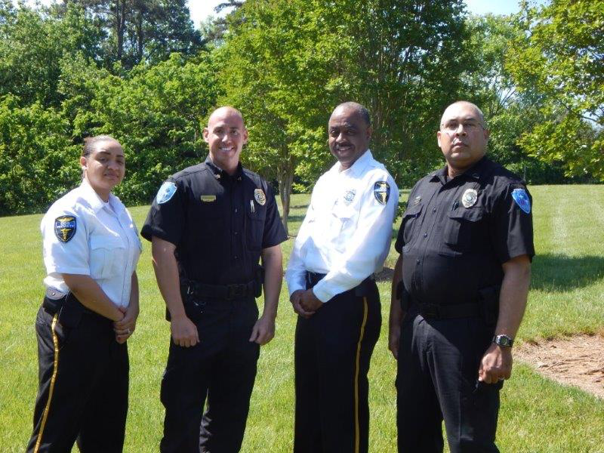

The uniforms of the Security Officers are distinctly different than those worn by our Company Police however their commitment to support and protect people of Durham County is the same.

Through pro-active efforts, the ODS Security Officers and Company Police work in a partnership to best identify and address unsafe conditions protecting people and property.

ODS Security Officers are expected to ensure guests receive a welcoming greeting to the Durham County facilities and where suspicious activity and persons are observed, to graciously enforce the policies and laws affecting Durham County.

To prepare ODS Security Officers for their serving as an integrated component of the Durham County staff, training is provided on a multitude of topics such as customer engagement, CPR and CPI Non-Violent Crisis Intervention. The Security Officers are expected to use their presence and verbal skills to help resolve tensions that arise and are also equipped with additional tools for situations that require a higher level of intervention.

The ODS Security Officers will, of course, perform technical security and safety responsibilities such as screening those who come to Durham County facilities, monitoring and respond systems alarms, and patrolling the building and grounds to provide visible presence. Done right, these functions will blend into visible customer engagement the ODS Security Officers bring to support those working at and visiting Durham County facilities. In fact, ODS has been humbled to have the opportunity at many clients to participate in community events such National Night Out, parades and others that incorporate ODS into communities we serve.

ODS is honored to work alongside the Durham County staff members serving the citizens and guests to Durham County facilities.